2.4 Orange Local Environmental Plan - Amendment 33 - Rosedale Gardens

RECORD NUMBER: 2021/2345

AUTHOR: Craig Mortell, Senior Planner

**EXECUTIVE Summary**

Council is in receipt of a draft Planning Proposal to rezone land 463 Leeds Parade and 440 Clergate Road, Orange. Referred to as Rosedale Gardens the site encompasses the former abattoir and adjoining farmland and was previously rezoned under Amendment 13. Following a review of the residential market the landowner is now requesting a further change to increase the number of lots by reducing the minimum lot size on the land and simplifying the zoning pattern.

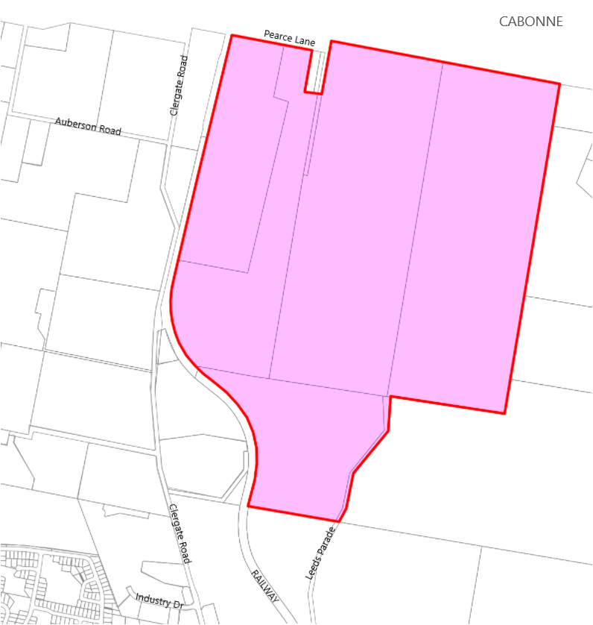

This matter relates to the draft Orange Local Housing Strategy (**OLHS**) previously reported to Council on 19 October 2021. If adopted the overall lot yield for Rosedale Gardens would increase from 450 lots to 700 lots representing 1 additional year of supply. With such an increase added to the supply the OLHS would remain within the intended 20 year planning horizon.

**Link To Delivery/OPerational Plan**

The recommendation in this report relates to the Delivery/Operational Plan strategy “7.1 Preserve - Engage with the community to develop plans for growth and development that value the local environment”.

**Financial Implications**

Nil

**Policy and Governance Implications**

Council has recently resolved to place the draft OLHS on public exhibition. There is a degree of overlap between this proposal and the draft OLHS, the public may question why this proposal can proceed before the draft OLHS has been resolved. This proposal is not considered to be inconsistent with the draft OLHS and will still need to obtain a gateway determination from the NSW Department of Planning, Industry and Environment (**DPIE**) before exhibition can occur, however exhibition may still overlap with the exhibition period of the draft OLHS.

**DIRECTORS NOTE**

This report relates to draft Planning Proposal to rezone land 463 Leeds Parade and 440 Clergate Road, Orange known as Rosedale Gardens. The subject land encompasses the former abattoir and adjoining farmland that was previously rezoned under Amendment 13 to Orange LEP 2011 in 2019 to provide for 450 large lot residential lots. The proposal now before Council seeks to increase the number of lots by reducing the minimum lot size on the land and simplifying the zoning pattern to provide for a residential development capped at a maximum of 700 large lots.

It is considered that the planning proposal as presented has merit and may be progressed to Gateway with the Department, however it should be noted that there remains several significant issues that will require further work by the proponent to resolve as discussed in the body of this report. It is recommended that the Planning Proposal retains the Urban Release Area designation at this stage pending preparation and adoption of a site specific Development Control Plan incorporating the matters in the attached Rosedale Gardens DCP scope of works required document, and a site specific Development Contributions Plan to address infrastructure requirements.

*Do not delete this line*

|  |
| --- |
| **Recommendation**   1. **That Council advise the proponent of the need for the Planning Proposal to retain the Urban Release Area designation pending preparation and adoption of the following documents that must address the matters raised in this report to the satisfaction of Council:**    * **A site specific Development Control Plan incorporating the matters in the attached Rosedale Gardens DCP scope of works required document, and**    * **A site specific Development Contributions Plan or inclusion within a review of the LGA wide contributions plan** 2. **That staff forward the Planning Proposal to the Department of Planning, Industry and Environment requesting a Gateway Determination, with the recommendation that:**    * **The Planning Proposal be required to retain the current Urban Release Area designation,**    * **The steepest portions of the site, being areas with a slope exceeding 20%, be added to Schedule 5 of SEPP (Exempt and Complying Development Codes) to reduce the risk of landslip potential arising from inappropriate development, and**    * **Council requests any Gateway Determination confirm the preferred mechanism for capping the site at 700 residential lots (excluding any lots created for non-residential purposes, such as open space dedications and the like).**    * **Should the Gateway seek substantive changes to the proposal that Council be provided the opportunity to further review and consider such changes before proceeding further.** 3. **That upon receipt of a Gateway Determination staff proceed with any relevant conditions, consultations and exhibitions required before reporting the matter back to Council.** |

*Do not delete this line*

**further considerations**

Consideration has been given to the recommendation’s impact on Council’s service delivery; image and reputation; political; environmental; health and safety; employees; stakeholders and project management; and no further implications or risks have been identified.

**SUPPORTING INFORMATION**

**Background**

On 1 March 2016 Council first considered a report for a planning proposal that became Amendment 13, to rezone the former abattoir site in Leeds Parade and associated farmland to the north of the abattoir to allow for a potential residential lifestyle estate of approximately 450 lots, mainly 1 acre (4000m2) with some 2 acre (8000m2) lots. Originally called Clergate Hills by the proponent the project was subsequently renamed ‘Rosedale Gardens’.

After a lengthy process related to the drafting of Blayney Cabonne Orange sub-regional Rural and Industrial strategy (**BCO**) amendment 13 was ultimately exhibited between 4 October 2019 and 1 November 2019 and endorsed by Council in December 2019, subject to the site becoming an Urban Release Area requiring preparation of a Development Control Plan to address a range of matters.

**Land use zones**

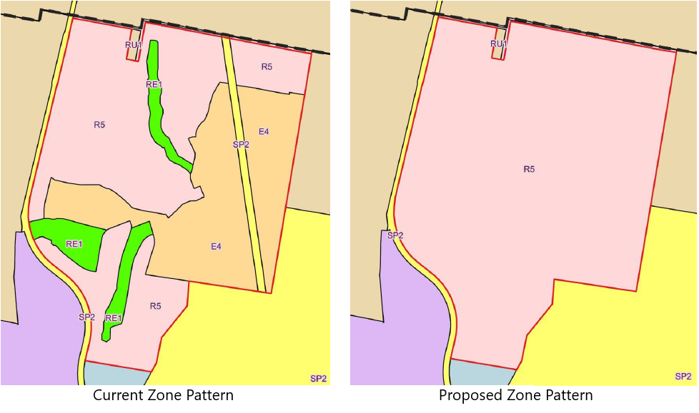

Amendment 13 changed the site from IN1 General Industrial and RU1 Primary Production to a mix of zones R5 Large Lot Residential, E4 Environmental Living, RE1 Public Recreation and SP2 Electrical Transmission Line. This responded to a conceptual plan for 450 residential lots between 4,000m2 and 8,000m2 in size. The current proposal seeks to increase the R5 Large Lot Residential zone to encompass the entire site.

**Subdivision - Minimum Lot Size**

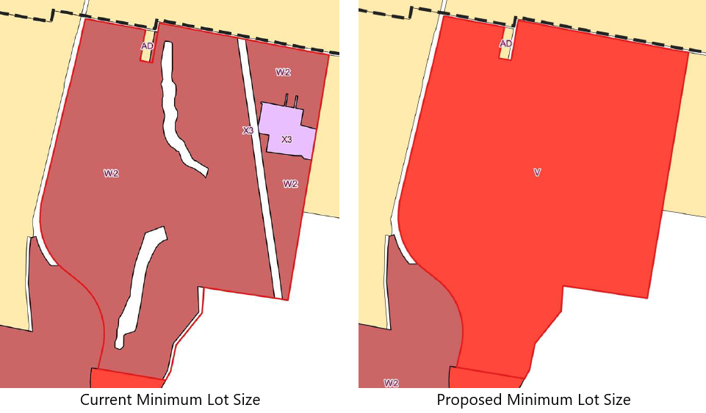

Similarly, amendment 13 established a combination of minimum lot sizes, predominantly W2 (4,000m2) with some X3 (8,000m2) and the current proposal is seeking to establish a uniform 2,000m2 across the entire site to allow for greater flexibility in designing the final subdivision layout.

**Urban Release Area**

Under the LEP a site may be mapped as an Urban Release Area (**URA**). The effect of URA mapping is to allow the rezoning of a site to proceed but prevent actual development until such time as a range of matters in Part 6 of the LEP are satisfied. Clause 6.1 relates to State public infrastructure, clause 6.2 relates to public utility infrastructure and clause 6.3 relates to the need for a Development Control Plan.

**Flexibility in design – Lot Yield Cap**

The proposal has nominated a simplification of the zone and lot size maps to allow for increased flexibility in the final design. A single zone of R5 is proposed with a single minimum lot size of 2,000m2 and a local clause to control the overall number of lots to be developed across the estate.

While this has some merit in allowing the design to adapt to market needs and any constraints emerging from further survey work, it does create concern for scope creep that could degrade urban design and ecological outcomes. The proposed clause for controlling the number of lots in the estate has been modelled on a similar clause in the Cessnock LEP and would have wording similar to the following:

***7.X  Certain land at Leeds Parade, Clergate Road and Pearces Lane, Orange***

1. *This clause applies to land at 440 Clergate Road and 463 Leeds Parade, Orange being Lots 2 & 3, DP 255983 and Lots 14, 15 and 25 DP 6694, as shown edged heavy black, shaded pink and identified as “Item 6” on the*[*Additional Permitted Uses Map*](https://www.planningportal.nsw.gov.au/publications/environmental-planning-instruments/cessnock-local-environmental-plan-2011)*.*
2. *Development consent must not be granted to any development on the land to which this clause applies if the granting of that consent would result in the total number of residential allotments on that land exceeding 700.*
3. *This clause does not prescribe a development standard that may be varied under this Plan.*

There are some vulnerabilities of this approach. For instance if an early stage of the estate creates lot(s) of 4,000m2 or greater and the estate is yet to be completed then buyers of such lots could seek a two lot subdivision on the basis that the estate has not yet reached the cap of 700 lots. This would potentially reduce the number of lots that can be approved in the final stage(s) of the estate.

Presumably early stage larger lots would be created in response to site constraints and/or as a method of protecting significant flora and fauna in the yards of larger lots where building envelopes act to prevent clearing. The push to allow small two lot subdivisions could erode these outcomes. This issue will be need further analysis as a part of the preparation of the DCP.

**Development Control Plan**

A site specific Development Control Pan required under section 6.3 of the LEP must address the matters below listed *(a)* to *(j):*

1. *a staging plan for the timely and efficient release of urban land, making provision for necessary infrastructure and sequencing,*
2. *an overall transport movement hierarchy showing the major circulation routes and connections to achieve a simple and safe movement system for private vehicles, public transport, pedestrians and cyclists,*
3. *an overall landscaping strategy for the protection and enhancement of riparian areas and remnant vegetation, including visually prominent locations, and detailed landscaping requirements for both the public and private domain,*
4. *a network of passive and active recreational areas,*
5. *stormwater and water quality management controls,*
6. *amelioration of natural and environmental hazards, including bush fire, flooding and site contamination and, in relation to natural hazards, the safe occupation of, and the evacuation from, any land so affected,*
7. *detailed urban design controls for significant development sites,*
8. *measures to encourage higher density living around transport, open space and service nodes,*
9. *measures to accommodate and control appropriate neighbourhood commercial and retail uses,*
10. *suitably located public facilities and services, including provision for appropriate traffic management facilities and parking.*

Attached to this report is a preliminary scope of works required for the preparation of a Rosedale Gardens specific Development Control Plan. This scope has included the matters raised by staff across a range of issues and is structured to align with the matters listed in section 6.3 of the LEP above.

**Development Contributions Plan**

Council staff are currently reviewing the section 7.11 contributions plans for the entire LGA, which is anticipated to be presented to Council around March / April 2022. Preparation of that plan is aware of this site having existing potential for 450 lots and that the proponent is seeking to increase this to 700 lots.

Given the timing of this planning proposal it is likely that Council will be considering exhibition of the new contributions plan at around the time that it may also be considering a post exhibition report for this planning proposal.

In that event, the development control plan for the site would be expected to include provision for the dedication to Council of such infrastructure and facilities as are wholly required by the development itself and a separate standalone contributions plan if required.

Alternatively, finalisation of this planning proposal could be made conditional upon the adoption of the new LGA-wide contributions plan.

**Relationship to Orange Local Housing Strategy (OLHS)**

While the site totals 293.45ha the proposal nominates a local clause to cap subdivision of the site at 700 lots. Without such a clause the proposed minimum lot size could in theory result in roughly 1,027 lots (293.45ha – 30% constraints and roads = 205.41ha / 2000m2). In practice some lots on steeper land will always need to be larger and this would reduce the yield below the 1,027 figure.

Given the proposed cap, the draft OLHS has factored in the 700 lots proposed in the land supply calculations.

**Water supply and security**

The DCP masterplan will need to include provision for trunk water main(s) installation with the western crossing of the railway and the potential requirement for a water storage reservoir at a high point of elevation on or adjacent to the land, subject to further investigation to ensure appropriate water pressure is achieved.

The Planning Proposal mentions stormwater harvesting in section 4.2 stating

*Harvesting of water for potable purposes would be developed in conjunction with Orange City Council to augment the Council water supply and offset the additional demand generated by the development of the land*

Council’s water and sewerage strategic manager advises that there would not be enough run-off generated to make this a viable secure yield option when stacked against cost. It does not currently form part of OCC’s long-term secure yield strategy and if this were to proceed then it would be at the full cost of the developer.

In view of the above it is considered that the stormwater management approach to the estate should be explored further as part of the DCP masterplan process. While stormwater harvesting may not be economically viable at this time there remains some logic to designing the estate in a manner that could enable such harvesting at a future point should the need arise.

**Transgrid Transmission Line**

The proponent advises that they have commenced negotiations with Transgrid to place the existing overhead 132kVA transmission line underground and re-oriented along proposed internal roads. A letter from the Central West Power Construction (**CWPC**) to Premise is attached to this report that confirms the negotiations are underway and that the proponent is aware of the costs and time involved and is willing to proceed and cover the costs involved.

This approach can work, but can also be costly and time-consuming to arrange the necessary Transgrid approvals. At the time of writing this report there is no definitive advice from Transgrid on this matter. While it is likely that they will support the undergrounding for the reasons outlined in the CWPC advice this is not a matter that Council can control. From a planning perspective staff support the undergrounding of the transmission line, again for the reasons outlined in the CWPC letter provided it is at no cost to Council and is the sole responsibility of the developer.

Should the proposal fail to achieve Transgrid approval, for any reason, the conceptual layout would need to be altered and the SP2 Electrical Transmission Zone retained or relocated to any new overhead path. Roads could still be placed across the SP2 zone but would need to be located clear of any towers or other assets. In such a circumstance ongoing maintenance of the SP2 zone would be a matter for the developer to resolve with Transgrid and it is not proposed that Council should acquire the land (and maintenance costs) for a transmission line easement.

Early stages of the estate would be unaffected by this issue and it may lead to the matter being deferred, in that instance the SP2 zone should be retained until such time as Council has advice from Transgrid that alternative arrangements are satisfactory to them have been confirmed.

Given the above it is likely that any gateway determination will require consultation with Transgrid to confirm the status of the transmission line, should this result in the power line remaining overhead or repositioned then the proposed zone for the land would need to be adjusted to include an SP2 corridor over the transmission line prior to public exhibition.

**Rail corridor**

The proponent has consulted with John Holland Rail (**JHR**), current manager of the Country Regional Network (**CRN**) owned by Transport Asset Holding Entity (**TAHE**), while Transport for NSW (**TfNSW**) is the rail authority for the CRN. The JHR contract is due to expire with UGL taking over in the new year.

JHR/UGL are responsible for reviewing the development to ensure potential impacts on rail operations (current and future) are considered and addressed. The Proposal for a rural subdivision requires two separate processes such as the DA review and an approval process for upgrading of the level crossings.

Attached is advice from JHR to the proponent in terms of the process without expressing a view on whether or not the level crossing upgrades sought would be achievable or supportable by JHR or TfNSW.

Accordingly it is considered that any Gateway Determination will require consultation with JHR/UGL and TfNSW prior to public exhibition to confirm all requirements in relation to level crossing upgrades. In the event that upgrading and use of the rail level crossings is not attainable the proponent would be expected to submit a revised traffic study as part of the DCP master-planning process.

**Ecological Values**

The planning proposal states:

*A preliminary biodiversity analysis was completed in support of the original planning proposal applying to the land. That assessment was prepared to address the requirements of the (then) Native Vegetation Act 2003. The inception of the NSW Biodiversity Conservation Act, 2016 (BC Act) means that any development application that would result in the clearing of native vegetation must consider whether the Biodiversity Offset Scheme (BOS) applies.*

*Future subdivision of the land will trigger the BOS due to the presence of native vegetation on the site and the anticipated level of clearing. Any future Development Application to subdivide the land will therefore need to be accompanied by a Biodiversity Development Assessment Report (BDAR), which will assess the potential impact on biodiversity in accordance with the Biodiversity Assessment Method (BAM) established under the BC Act.*

*An accredited assessor must implement the BAM and prepare a BDAR in accordance with part 6 of the BC Act. A preliminary site visit to the property was completed by Premise ecologists on the 8-9 April 2021. Further vegetation surveys are required to satisfy the requirements of the BAM to adequately identify PCTs (Plant Community Types) and collect quantitative data for input into the BAM Calculator to determine any offset liability.*

*Database searches have predicted the presence of threatened flora, fauna and ecological communities to occur on the site. 13 threatened flora species, 40 threatened fauna species and 2 threatened ecological communities are possible on the site.*

*Whilst further fauna and flora surveys need to be completed to finalise the biodiversity strategy for the planned subdivision (ahead of any future DA lodgement), the proposal is considered capable of complying with the provisions of the Biodiversity Conservation Act 2016.*

Council’s City Presentation Manager has advised that the proposal should retain all of the native vegetation in the south western portion of Lot 3 DP 255983 located between the existing property access track (from the railway) to the southern boundary as either public lands, estate managed public open space or on individual allotments with building envelopes (encompassing dwellings, detached garages and sheds) identified for each individual property minimising native tree removals. Furthermore, remnant vegetation along the existing water courses should be retained with no earthworks permitted within the Tree Protection Zones.

To achieve the intended living environment proposed it would be more achievable if the subdivision was managed as a private residential estate with private open space areas, managed and maintained as part of the estate. Council’s involvement should be limited to managing the road reserve and roadside street tree planting with all other landscaping and water features managed by the estate.

This outcome would need to be a requirement of any DCP masterplan for the estate. The proponent response to this matter confirms that the intent for the area of vegetation mentioned is that a portion of the native woodland be retained as public land. Further assessment will be made at the DCP masterplan and DA stages, this will allow for final flora and fauna mapping and surveys to be completed and an overall assessment of the biodiversity strategy for the estate.

The proponent asserts that the detailed assessment is unlikely to impact on the road and open space corridor but that an adjustment of lot sizes is a possible outcome. While this approach could work it is considered that there is a high probability that a gateway determination may require additional studies and design responses prior to public exhibition.

**Topography and slope analysis**

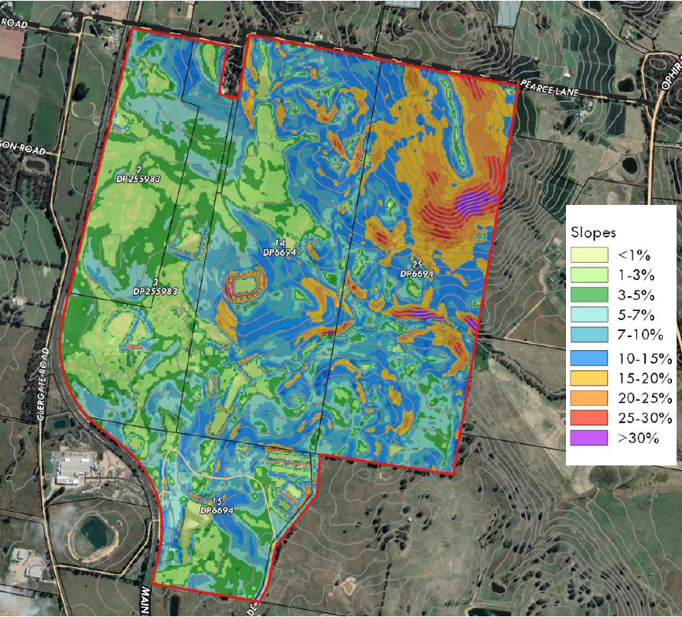

The site ranges from relatively flat areas in the west through to extremely steep areas in the north-eastern corner of the site. The extent of earthworks likely to be required for a residential subdivision relates to the lot sizes involved. Larger lots typically require less land shaping at the subdivision stage to produce lots that have viable building sites. In this regard it is likely that the north-eastern areas of the site will need to be larger in size to account for the steep topography.

Roads should ideally avoid the steepest areas of the site to reduce the risk of landslip. Geotechnical investigations and engineering solutions can enable development on steep lands, but at an increased cost for retaining walls and the like. While largely a matter for DA assessment it should be highlighted in the DCP masterplan as an issue that needs to be addressed.

As part of seeking a gateway determination Council should request the Department of Planning, Industry and Environment to exclude the steepest areas, from SEPP (Exempt and Complying Development Codes) to further mitigate the risk arising from inappropriate development on steeply sloping areas.

**Interface with adjoining lands**

To the north of the site is Cabonne Shire and lands used predominantly for horticulture and agriculture. This pattern continues to the north eastern boundary where an orchard spans across the LGA boundary. To the west the site is bounded by the railway line and to the south the site meets lands owned by Charles Sturt University. Each of these interfaces need to be carefully designed to

* Minimise disruption to primary production,
* Prevent rail vibrations from damaging buildings, and
* Preserving the operations of a public university.

By maintaining the URA mapping Council can require appropriate interface treatments as part of the Development Control Plan. This can comprise larger lots with increased depth and placement of building envelopes away from the estate edge to allow for greater physical separation. Additionally significant landscaping requirements around the estate edge to limit issues of odour and spray drift from creating conflicts between neighbours.

**Traffic and access**

Council staff have reviewed the traffic portion of the planning proposal and confirm the numbers and assessment are appropriate and consistent with expectations. The volumes generated do warrant upgrading of the following intersections:

* Leeds Parade and the Northern Distributor Road
* Clergate Road and the Northern Distributor Road,
* Clergate Road and Farrell Road

These upgrades will be included in the Section 7.11 Developer Contributions Plan currently being worked on by staff. However it is likely that the contributions plan may not have the capacity to fully fund all of these works and the proponent may therefore be required to enter into a planning agreement with Council to address these off site aspects.

Should approval to use the level crossing(s) onto Clergate Road be denied by the rail authority it will impact which intersections will require upgrading.

**Road design and construction**

The Planning Proposal states an intention to use table-drains rather than kerb and guttering. This is not presently supported by staff, especially in terms of roads in steeper areas of the site and will need to be revisited as part of the DCP masterplan exercise.

**Conceptual Layout**

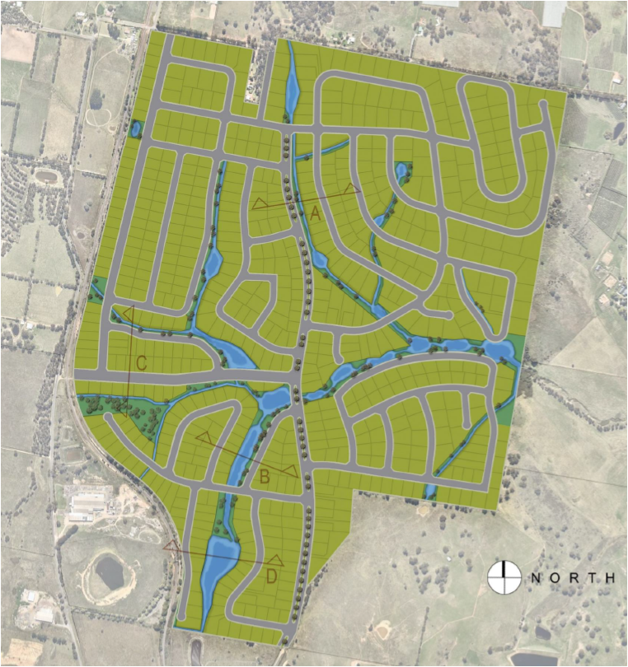Although the layout supplied in the Planning Proposal is purely for illustrative purposes staff have identified a number of concerns and issues that would need to be resolved during the DCP masterplan process.

* A loop road in the north east corner of the proposal should remove the section of road adjoining Pearces Lane as it is a duplication and would require removal of significant remnant vegetation.
* The road running along the eastern boundary could be redesigned with a better outcome both in terms of slope and retaining vegetation
* Pedestrian/cyclist bridges over the creek lines and waterways should be considered as a means of reducing travel distances for alternative travel modes; particularly where streets or cul-de-sacs face each other across a section of open space.
* Active transport connections to and from North Orange and beyond. Clergate Road is already a key loop for cyclists and can be hazardous given the industrial uses to the south and current residential traffic. Separate active transport routes need to be considered given the increased traffic movements (as per the TIA).
* Overall block lengths between intersections should be capped at 300m to encourage permeability.
* Irregular shaped blocks should be minimised, or have appropriate building envelopes nominated.
* Visual privacy between lots on steeply sloping land needs to be carefully managed and subdivision design should be amended or supported by a visual impact analysis to demonstrate that lower lying lots will not be overly monitored by higher neighbours – 9m separation is not considered sufficient in highly sloping conditions.
* Additional information and assessment of lot layouts having regard to existing vegetation on the property. To this end the future Master Planning for the precinct is to be accompanied by a detailed landscape assessment showing existing trees, trees proposed to be removed and an overall landscape concept plan for the subdivision layout.

**Consistency with Regional Plan**

The Central West and Orana Regional Plan 2036 is the NSW Government’s strategy for guiding land use planning decisions for the Central West and Orana Region for the next 20 years. At its heart is a core vision for the region supported by four supporting goals:

* The most diverse regional economy in NSW
* A stronger, healthier environment and diverse heritage
* Quality freight, transport and infrastructure networks
* Dynamic, vibrant and healthy communities.

The proposal is considered to be generally consistent with the objectives and actions of the Plan. More detail is available in Table 1 of section 4.3 of the planning proposal.

**Consistency with SEPPs**

The Planning Proposal has examined and responded to the following State Environmental Planning Policies

*SEPP 55 – Remediation of Lands*

A preliminary site investigation was performed as part of the previous rezoning of this site (Amendment 13) which found the site was suitable for residential use. The current proposal relies upon those findings and the increased yield does not affect those conclusions.

*SEPP (Infrastructure) 2007*

In recognition of the increased density from Amendment 13 the current proposal has been supported by a revised Traffic Impact Assessment (TIA) – refer appendix C of the planning proposal. The revised TIA found:

* *The development is expected to generate approximately 5,180 vehicle movements per day, and 546 and 497 vehicle movements (two-way total) in the morning and evening peak hours respectively;*
* *Site traffic will have a minor impact on the surrounding road network, with modest increases to queue lengths and delays, and the traffic volumes can be accommodated on the road network in a safe and efficient manner;*
* *The access locations allow traffic to be distributed on the road network and they are not expected to create any operational or safety issues at the nearby railway level crossings;*
* *Car parking for the individual lots is to be provided in accordance with the DCP, with on-street parking provided for visitors; and*
* *It is recommended that future consideration be given to providing sustainable transport facilities within the site that link with existing bus routes and shared paths.*

On the basis of the above the TIA supported the proposal. Council engineers have reviewed the TIA and found its assumptions and numbers to be well founded. Clearly if the proponent is unable to achieve support from the rail authorities for the level crossing upgrades then a revised TIA would be required to inform the DCP masterplan exercise.

*SEPP (Vegetation in Non Rural Areas) 2017*

The Planning Proposal acknowledges the role of the SEPP in regulating tree removal on smaller residential lots where the Biodiversity Conservation Act does not apply. The proposal states that a site specific DCP would be prepared to further address vegetation protection and that on this basis consistency with the SEPP can be achieved. Staff support this view.

**Ministerial Directions**

Under section 9.10 of the Environmental Planning and Assessment Act the Minister can provide directions that must be taken into account, where relevant, during the preparation of any LEP amendment. In this respect the Planning Proposal has identified and responded to the following Ministerial Directions

*Direction 2.1 Environmental Protection Zones*

The objective of the direction is to protect and conserve environmentally sensitive areas. Where the direction applies, a relevant planning authority must ensure that:

(4) A planning proposal must include provisions that facilitate the protection and conservation of environmentally sensitive areas.

(5) A planning proposal that applies to land within an environment protection zone or land otherwise identified for environment protection purposes in a LEP must not reduce the environmental protection standards that apply to the land (including by modifying development standards that apply to the land). This requirement does not apply to a change to a development standard for minimum lot size for a dwelling in accordance with clause (5) of Direction 1.5 “Rural Lands”.

Part of the land is currently zoned E4 – Environmental Living which was created to provide additional protections for remnant vegetation. The lot size applying to the E4 lands is consistent with the adjoining R5 lands and the Planning Proposal regards the vegetation SEPP as providing the appropriate mechanism to safeguard the vegetation.

In the view of staff the more significant areas of remnant / native vegetation should be either provided in a communal open space managed by the estate under a community title arrangement or alternatively incorporated within the yards of larger lots subject to building envelope restrictions. Accordingly staff agree, subject to the DCP masterplan, that the objective of Direction 2.1 can be satisfied.

*Direction 3.1 Residential Zones*

The objectives of this direction are:

* to encourage a variety and choice of housing types to provide for existing and future housing needs,
* to make efficient use of existing infrastructure and services and ensure that new housing has appropriate access to infrastructure and services, and
* to minimise the impact of residential development on the environment and resource lands.

Direction 3.1 is applicable where:

1. an existing or proposed residential zone (including the alteration of any existing residential zone boundary),
2. any other zone in which significant residential development is permitted or proposed to be permitted.

The Planning Proposal seeks to expand the area of the R5 zone (at the expense of the E4 and SP2 zones) and will be adequately serviced. Potential impacts of the residential development on the environment and resource lands are considered to be minor given the current residential status of the site and does not reduce the permissible density of the land.

*Direction 3.4 Integrating Land Use and Public Transport*

The objectives of this direction are to:

* ensure that urban structures, building forms, land use locations, development designs, subdivision and street layouts achieve the following planning objectives:
  + improving access to housing, jobs and services by walking, cycling and public transport, and increasing the choice of available transport and reducing dependence on cars, and
  + reducing travel demand including the number of trips generated by development and the distances travelled, especially by car, and
  + supporting the efficient and viable operation of public transport services, and (e) providing for the efficient movement of freight.

The indicative concept plan demonstrates that there is potential to provide interconnected pedestrian and cycle networks that have the capacity to be linked to the existing networks accessing the Charles Sturt University Campus and future networks throughout the North Orange residential areas. Road connections are designed to support public transport (if required). This would meet the objectives of current transport guidelines and planning policies, and therefore the proposal is not inconsistent with the direction.

*Direction 4.4 Planning for Bushfire Protection*

This direction applies when a relevant planning authority prepares a planning proposal that will affect, or is in proximity to land mapped as bushfire prone land.

The Site contains a small portion of land identified as being bushfire prone. This portion of the site was understood to have been mapped as bushfire prone due to the existence of a stand of pine trees in the mapped area. These pine trees were cleared by the property owner several years ago however the bushfire prone land map has not been updated. Given the threat vegetation has been removed, and the very minor extent of mapped bushfire prone land, it is not considered likely that the proposal will result in any adverse impact on future residential development of the land,

*Direction 5.10 Implementation of Regional Plans*

Direction 5.10 seeks to give legal effect to the vision, land use strategy, goals, directions and actions contained in Regional Plans.

The direction applies to land to which a Regional Plan has been released by the Minister of Planning. The Central West and Orana Regional Plan has been approved and applies to the Orange LGA.

The Vision of the Regional Plan is:

*A unique part of Western NSW with a diverse economy, supported by the right infrastructure, an exceptional natural environment and resilient communities.*

The Vision of the Regional Plan is delivered by four key goals and 29 specific directions. Relevant to this planning proposal are a number of goals and directions, outlined and discussed in **Table 1** of the draft planning proposal.

*Direction 6.1 Approval and Referral Requirements*

Ministerial Direction 6.1 – Approval and Referral Requirements applies to all planning proposals forwarded for Gateway Determination by a local authority.

To be compliant with Direction 6.1, a planning proposal must be consistent with the following provisions;

“A planning proposal must:

1. Minimise the inclusion of provisions that require the concurrence, consultation or referral of development applications to a Minister or public authority, and
2. Not contain provisions requiring concurrence, consultation or referral of a Minister or public authority unless the relevant planning authority has obtained the approval of:
   1. The appropriate Minister or public authority, and
   2. The Director-General of the Department of Planning (or an officer of the Department nominated by the Director-General), prior to undertaking community consultation in satisfaction of section 57 of the Act, and
3. Not identify development as designated development unless the relevant planning authority:
   1. Can satisfy the Director-General of the Department of Planning (or an officer of the Department nominated by the Director-General) that the class of development is likely to have a significant impact on the environment, and
   2. Has obtained the approval of the Director-General of the Department of Planning (or an officer of the Department nominated by the Director-General) prior to undertaking community consultation in satisfaction of section 57 of the Act”.

The proposed planning proposal does not generate the need for any explicit concurrence, consultation or referral to the Minister or public authority and is therefore consistent with Direction 6.1.

*Direction 6.3 Site Specific Provisions*

Ministerial Direction 6.3 – Site Specific Provisions applies to all planning proposals forwarded for Gateway Determination by a local authority.

To be compliant with Direction 6.3, a planning proposal must be consistent with the following provisions:

1. A planning proposal that would amend another environmental planning instrument in order to allow a particular development proposal to be carried out must either:
   * Allow that land use to be carried out in the zone the land is situated on, or
   * Rezone the site to an existing zone already applying in the environmental planning instrument that allows that land use without imposing any development standards or requirements in addition to those already contained in that zone, or
   * Allow that land use on the relevant land without imposing any development standards or requirements in addition to those already contained in the principal environmental planning instrument being amended.
2. A planning proposal must not contain or refer to drawings that show details of the development proposal.

The planning proposal is consistent with the above.

**Conclusion**

While the planning proposal as presented is considered to have merit and may be progressed, several significant issues will require further work by the proponent to resolve. If submitted to the Department of Planning, Industry and Environment for a gateway determination there is a distinct possibility that any determination will require additional studies and resubmission to the department prior to being allowed to progress to public exhibition. Notwithstanding this the site is already zoned for up to 450 residential lots and the increase in density to 700 lots is unlikely to raise entirely new or unresolvable issues. The proponent is aware of the need to obtain the support of the rail authority and transgrid in order to progress and that Council is not able to override any objections those authorities may have. Accordingly, Council may support the proposal at this time on the understanding that the Gateway process may confirm additional works and potential changes to project. Should such changes be substantial the matter may need to be reviewed further and reported back to Council.

*Do not delete this line*

**Attachments**

1 Draft Planning Proposal - Rosedale Gardens - 250 additional lots, D21/68753

2 Rosedale Gardens DCP - scope of work required, D21/67523

3 email between John Holland Rail and proponent - advice on rail crossing upgrades, D21/68757

4 Central West Power Construction - Advice on undergrounding the transmission line, D21/67457